PEPTIDEPURE.COM
Comprehensive Website Audit Report
March 27, 2026 | Prepared for Dr. Scott Mortensen

For Peptide Pure staff: we can update the website here: https://www.peptidepure.com/admin
TO DO — peptidepure.com — Zlatin
1. Fix the "How to Get Started" page (peptidepure.com/how-to-get-started)
Add 4 downloadable PDFs at the bottom of the page in this folder:
https://drive.google.com/drive/folders/1xM038Ss9RifxeAa1GRmXkurI-jCqtw_U?usp=drive_link
- PPRN_001_2025_Protocol_Summary.pdf
- PPRN_Informed_Consent_Template.pdf
- PPRN_Data_Capture_Best_Practices.pdf
- PPRN_Adverse_Event_Report_Form.pdf
2. Fix the Forms / Downloads section
- Create a dedicated Forms page with the following built in as copy-paste-ready embedded fields, not just PDFs:
  - SOAP Note / Data Capture form — at the top of the page. Should have fields a provider can fill in directly on-site (patient info, subjective, objective, assessment, plan). (See Onzen.ai example if needed)
  - Adverse Event Report — embed below the SOAP note with fillable fields (patient ID, treatment info, AE description, severity, causality, outcome).
- The idea is that providers can submit data directly on the site, not just download PDFs.
3. Add Legality & Compliance page
- New page: peptidepure.com/legality
- Content is in the Word doc I'm sending you in the folder:
https://drive.google.com/drive/folders/1xM038Ss9RifxeAa1GRmXkurI-jCqtw_U?usp=drive_link
(PeptidePure_Legality_Page_and_Zlatin_Instructions.docx).
- This is NOT legal advice — it's a transparency/disclosure page about the current regulatory landscape.
- Add a link to this page in the main nav and footer.
4. Fix Lost Password / Password Reset
- The password reset is not working. I tried resetting with mistermortensen@gmail.com and never received a reset email.
- Check the email delivery system (SMTP config, spam filters, etc.) and fix it so password resets actually send.
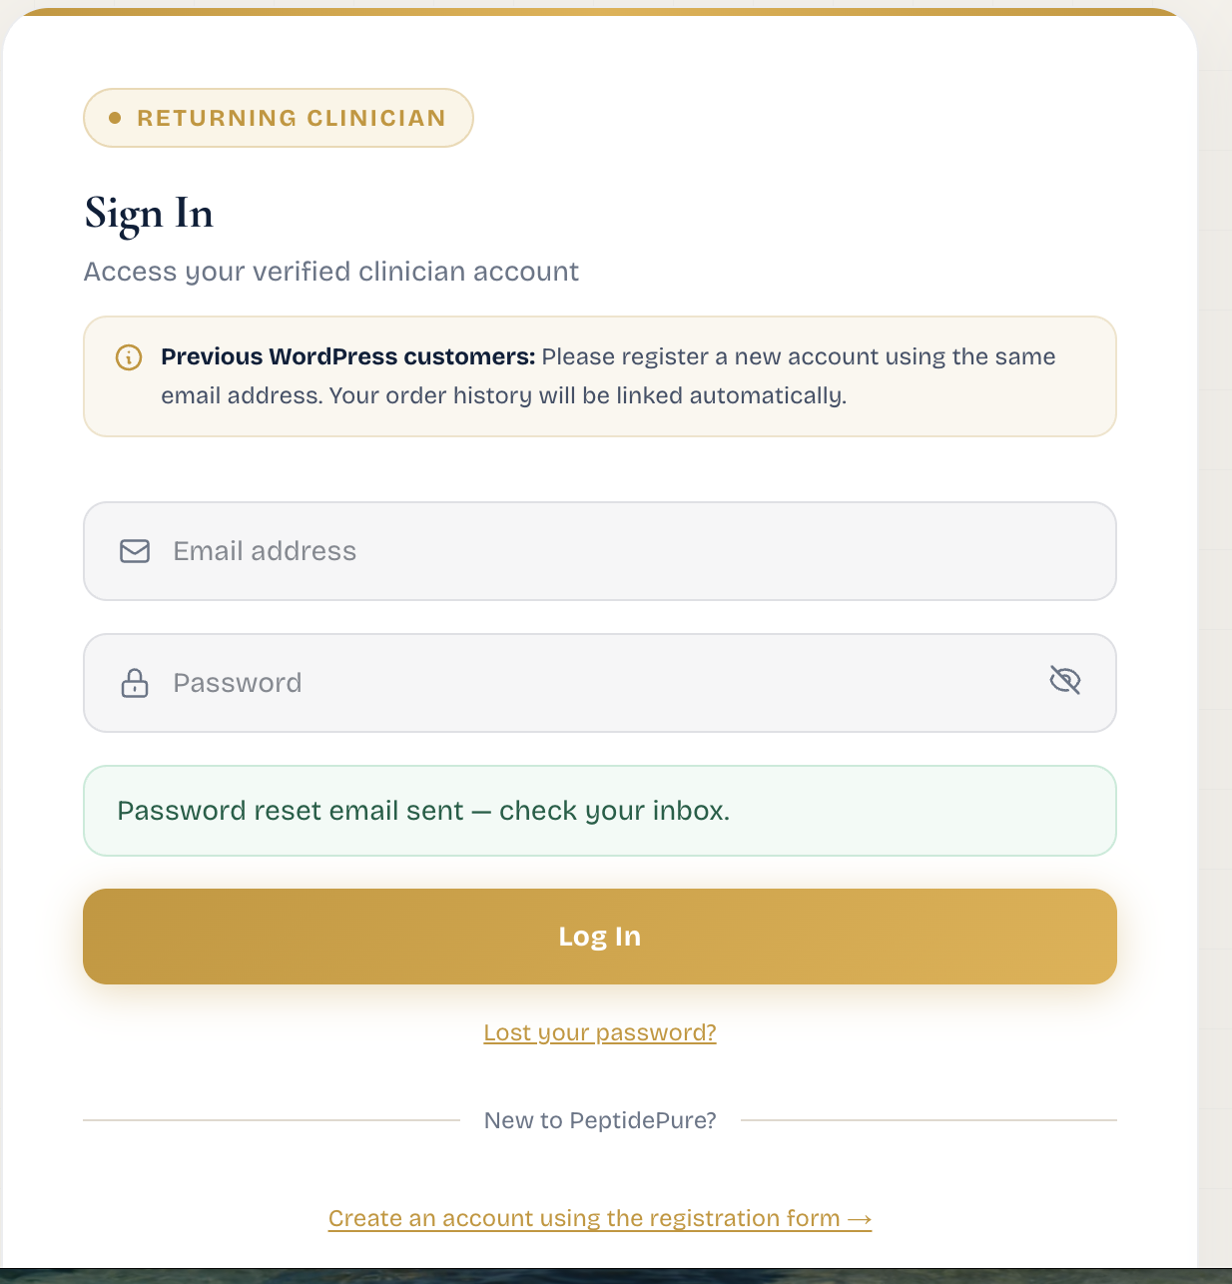

Executive Summary
The PeptidePure.com website is a professionally built Next.js application with strong front-end structure, comprehensive product catalog (84 products across 9 categories), well-designed clinical forms, and a complete legal section. The site loads fast, navigation is consistent, and no broken links were found across all 19+ pages audited.
However, several critical operational gaps need attention: form submissions and email delivery need backend verification, the SOAP data capture tool stores data only in the browser session (lost on close), the inventory page is read-only with no admin edit capability, and key email addresses (pamela@, dr.elaine@) are not prominently surfaced. Below is the full audit with specific findings and recommended actions.

One addition to Navigation www.peptidepure.com needs a page like this:
https://www.onzen.ai/getting-started.html

Audit Findings Summary
Area | Item | Status | Notes / Action Needed
Navigation | All nav links (19 pages) | PASS | Every link loads correctly, no 404s
Navigation | Footer links match nav | PASS | All footer quick links, legal links, support info consistent
Navigation | Mobile menu toggle present | PASS | Hamburger menu button exists for responsive view
Forms | Contact form (/contact) | ISSUE | Form exists with all fields. VERIFY: where do submissions go? Test email delivery.
Forms | SOAP Data Capture | CRITICAL | Browser-only storage. Data lost on close. Needs server-side persistence or export.
Forms | IRB Baseline form | ISSUE | Form complete with submit button. VERIFY: backend receives submissions.
Forms | IRB Treatment Log | ISSUE | Form complete with submit button. VERIFY: backend receives submissions.
Forms | IRB AE/SAE Report | ISSUE | Form complete with submit button. VERIFY: backend receives submissions.
Forms | Patient Outcomes | ISSUE | Only shows Provider/Patient radio toggle on load. May need interaction to reveal full form.
Email | info@peptidepure.com | PASS | Referenced throughout site (banner, footer, contact page, refunds page)
Email | pamela@peptidepure.com | CRITICAL | Not found anywhere on the site. Must be added.
Email | Form submission routing | CRITICAL | Cannot verify where contact/IRB forms send data. Must confirm backend email routing.
Admin | Change prices | CRITICAL | No admin panel visible. Next.js custom build needs /admin or CMS backend.
Admin | View user registrations | CRITICAL | Account page is customer-only. No admin user management visible.
Admin | Update inventory | CRITICAL | Inventory page is read-only. No edit capability from frontend.
Legal | Privacy Policy | ISSUE | Present but missing: effective date, HIPAA considerations, healthcare data handling specifics.
Legal | Terms & Conditions | PASS | Comprehensive. Covers research use, credentialing, IRB, liability, arbitration, CA law.
Legal | Shipping & Payments | PASS | Complete with methods, timeframes, accepted payments.
Legal | Refunds & Returns | PASS | Clear 7-day policy, proper exclusions for research-grade products.
Legal | Accessibility Statement | PASS | WCAG 2.1 Level AA commitment documented.
Content | Copyright year in footer | ISSUE | Shows © 2025. Should be updated to 2026.
Content | Product catalog | PASS | 84 products, 9 categories, pagination working, pricing displayed.
Content | COA Library | PASS | 7 COAs from 5 labs, purity table with 40+ entries, filter buttons work.
Content | Inventory page | PASS | Shows stock levels, search, status filters. Updated March 2026.

1. Navigation & Links
All 19+ pages load correctly with no broken links. The navigation structure is clean and consistent across every page:
- Main nav: All Peptides, How It Works, Our Company, COA, Inventory, Contact Us, Forms dropdown…ADD GETTING STARTED
- Forms dropdown: IRB Baseline, Treatment Log, AE/SAE Report, Patient Outcomes, SOAP Data Capture – WOULD BE NICE TO CONSOLIDATE - one downloadable PDF
- Footer: Quick Links (5), Legal (5), Support (phone, email, shipping hours)
- Account/Cart links present in header when logged in
- Announcement banner with $1,000 minimum order notice + info@ mailto link works

2. Forms & Data Capture

Contact Form (/contact)
The contact form has all required fields: Full Name, Email, Phone, Credential Type (MD/DO/PA-C/NP/ND/DC/Qualified Researcher), NPI Number, Subject dropdown (7 categories), and Message. Submit button present. However, the critical question is: where do submissions go? You need to verify the backend sends emails to the right addresses (info@, pamela@, dr.elaine@) and nothing gets lost.

SOAP Data Capture (/forms/soap-capture)
This is the biggest issue found. The SOAP capture form has excellent fields (Patient ID, Date, Clinician, Clinic/Site, Visit Type, Protocol, Week #) and a large textarea for pasting SOAP notes with an "Extract & Structure Data" button. However, the page explicitly states: "Stored in browser session only — not sent to any server." This means:
- All data is lost when the browser tab/window closes
- No server-side persistence, no database storage
- No export/download functionality visible
- The Session Record Log says "No records yet" with no visible save mechanism
Recommendation: Add server-side storage or at minimum a CSV/PDF export button so clinicians can retain their structured SOAP data. Consider encrypting at rest if storing server-side.

IRB Forms (Baseline, Treatment Log, AE/SAE)
All three IRB forms are well-designed with appropriate clinical fields, signature blocks, consent checkboxes, and submit buttons. The Baseline form covers demographics, conditions, medications, allergies, planned protocol, and dosing. The Treatment Log captures per-visit administration details. The AE/SAE Report is thorough with severity grading, outcome status, and follow-up tracking. All forms need backend verification to confirm submissions are received and stored properly.

Patient Outcomes Form
This form initially only shows a Provider/Patient role selector. The full form likely renders after selection, but the initial state may confuse users. Consider showing a preview or description of what comes next.

3. Email Configuration
You requested three email addresses work reliably. Here is the current status:
- info@peptidepure.com: Visible throughout the site (banner, contact page, footer, refunds page). Mailto links work correctly.
- dr.elaine@peptidepure.com: Only appears on the Terms & Conditions page in the contact section at the bottom. Not on the Contact page or footer. Should be added to relevant pages.
- pamela@peptidepure.com: Not found anywhere on the website. Needs to be added.
Critical action items for email: (1) Verify DNS records (MX, SPF, DKIM, DMARC) for all three addresses with your email provider. (2) Send test emails to/from each address. (3) Confirm the contact form backend routes submissions to the correct inbox(es). (4) Set up email forwarding rules if needed so Pamela, Elaine, and you each get copies. (5) Add pamela@ and dr.elaine@ to the Contact page or footer as appropriate.

4. Admin Capabilities
This is the second major gap. The site is a custom Next.js application (not Shopify, WooCommerce, or Squarespace), and there is no visible admin panel. The /account page shows a standard customer dashboard with: Dashboard, Orders, Addresses, Account Details, and Log Out. It does not provide:
- Price management: No way to change product prices from the frontend. This must be done in the codebase or a connected database/CMS.
- User registration visibility: No way to see new signups or manage user accounts. You’d need a database admin tool or custom admin page.
- Inventory updates: The /inventory page is public and read-only. Stock counts appear hardcoded or pulled from a data source with no edit interface.
Recommendation: Your developer needs to build an /admin dashboard (password-protected) or integrate a headless CMS (e.g., Sanity, Strapi, or a simple admin panel) so you, Pamela, and Elaine can manage prices, view registrations, and update inventory without touching code.

5. Legal & Compliance Section
The legal section is present and largely well-done. Five legal/policy pages exist:
- Terms & Conditions: Excellent. 14 sections covering acceptance, research use, credentialing, IRB participation, orders/pricing, shipping, warranty disclaimers, indemnification, privacy, IP, termination, governing law (CA), arbitration with class action waiver, and modifications. Effective date March 2026.
- Privacy Policy: Adequate but could be strengthened. Covers data collection, usage, sharing, cookies, security, user rights, third-party links. Missing: effective/last-updated date, specific HIPAA or healthcare data handling language (important for a clinician platform), California-specific rights (CCPA/CPRA), and data retention periods.
- Shipping & Payments: Complete. Standard/Express/International options documented, payment methods including crypto.
- Refunds & Returns: Well-structured. 7-day window, clear exclusions for opened/used products, process instructions.
- Accessibility Statement: WCAG 2.1 Level AA commitment with proper disclaimers about third-party content.
The homepage footer also contains a medical disclaimer stating Peptide Pure does not provide medical advice, prescribe treatment, or direct patient care. A research/education compliance notice appears at the bottom of the homepage as well.

6. Additional Observations
- Copyright year: Footer shows © 2025 — should be updated to 2026.
- AI Chatbot: An "Open PeptidePure AI assistant" button appears on every page. This is a nice touch for user support.
- Product catalog: 84 products across 9 categories with wholesale and retail pricing displayed. Pagination works (7 pages). Both individual products and protocol packages are available.
- COA Library: Impressive. 7 COAs from 5 independent labs (Forever Young Pharmacy, Freedom Diagnostics, Krause Analytical, MZ BioLabs, Vanguard Laboratory). Purity summary table with 40+ entries. Filter buttons by lab work correctly.
- Our Company page: Clean dual-entity structure explained (501(c)(3) research entity + Peptide Pure LLC). Operational standards, principles, and enrollment CTA.
- How It Works page: Good funnel with 3-step process, clinician benefits, market statistics ($150B market, 60+ FDA-approved peptides), and science section.

Priority Action Items
CRITICAL (Do Immediately):
- Build or enable an admin panel for price changes, user management, and inventory updates
- Verify all form submissions (contact + IRB forms) are reaching the correct email inboxes
- Add server-side storage or export to the SOAP Data Capture tool
- Set up and test pamela@peptidepure.com — add it to the site
- Verify DNS email records (MX, SPF, DKIM, DMARC) for all @peptidepure.com addresses
HIGH (This Week):
- Add dr.elaine@peptidepure.com to the Contact page (currently only on Terms page)
- Add effective date and HIPAA/healthcare data language to Privacy Policy
- Update footer copyright from 2025 to 2026
- Test Patient Outcomes form end-to-end (may need UI improvement after role selection)
NICE TO HAVE:
- Add CCPA/CPRA rights section to Privacy Policy (you’re governed by CA law per Terms)
- Add data retention period info to Privacy Policy
- Consider adding a dedicated email for admin notifications (order alerts, new registrations)

